Technical Proposal
Technical Support for Strengthening and Enhancement of Integrated Primary Education Management Information System (IPEMIS)

Prepared by: Riseup Labs


Table of Contents
1. Executive Summary 3
2. Understanding of Assignment 3
Key Proposal Principles 3
3. Scope Alignment 3
4. Proposed Technical Approach 4
1. Discovery and SRS Finalization 4
2. Modular Enhancement 4
3. Unified Data and Reporting Layer 4
4. API-Based Interoperability 4
5. Security, Audit and Performance Strengthening 4
6. Capacity Building and Handover 4
5. Development Methodology 5
6. System Architecture 5
7. Data Flow Approach 6
Data Flow Controls 7
8. Integration Roadmap 7
Integration Roadmap Steps 7
9 Security Framework 8
10. Development and Enhancement Strategy 8
Module Enhancement Strategy 8
11. Proposed Technical Stack 9
12. Deliverables 9
13. Testing and Quality Assurance 10
14. Governance, Reporting and Capacity Building 10
Governance Structure 10
Reporting 10
Capacity Building 11
15. Risks and Mitigation 11
16. Assumptions and Dependencies 11
17. Conclusion 11

1. Executive Summary
The Directorate of Primary Education (DPE), with support from UNICEF and development partners, has established IPEMIS as a nationwide education management platform supporting data-driven governance, monitoring, school-level planning, teacher management and service delivery. The ToR requests technical support to strengthen, enhance and integrate IPEMIS so that it remains stable, secure, scalable and usable for national, sub-national and school-level stakeholders.
This proposal presents a practical technical approach focused only on the ToR scope: enhancement of existing IPEMIS modules, API-based integration with national systems, improved UI/UX and dashboards, performance and scalability improvement, role-based access control, auditability, capacity building and operational support. The proposed approach avoids unnecessary new features and focuses on structured implementation, quality assurance, data reliability, interoperability, security and sustainability.

2. Understanding of Assignment
IPEMIS was launched nationwide in March 2022 and is already operational across the country with modules such as APSS, SLIP, TTMS, E-Monitoring, SEND, Non-Government School Registration, Scholarship and PEPMIS. The next enhancement stage is expected to support teacher workforce planning, teacher professional development, accountability, real-time reporting, module interoperability and citizen-facing services.
The official IPEMIS public portal currently shows a large active operational footprint including connected schools, teachers, students and textbook distribution statistics. This reinforces the need for a robust architecture, controlled enhancement process, strong testing, secure integrations and capacity building before broader rollout of updated modules.

Key Proposal Principles
- Build on the existing IPEMIS platform and avoid redevelopment unless a component is technically unfit.
- Enhance modules using configurable workflows, role-based access and validated data models.
- Use secure API-based interoperability for approved national systems and avoid manual data duplication.
- Strengthen dashboards and reporting so decision-makers can use real-time and disaggregated data.
- Implement security, audit trails, monitoring and backup as core platform capabilities.
- Transfer knowledge to DPE IMD and field resource teams to support long-term sustainability.

3. Scope Alignment
Scope Area | Proposal Coverage
Teacher Module | Enhance workforce analytics, teacher availability, subject/grade/location breakdown, gender balance, vacancy mapping and retirement projections.
Teacher Transfer Management System (TTMS) | Enhance transfer workflows for mutual, coordination and attachment transfers with policy-based rules, tracking, notifications and approval workflows.
LMS | Strengthen course pathways, learning prerequisites, progress tracking, assessment validation, certification and integration with teacher profiles.
Training Tracking System | Connect training delivery, LMS completion, modality-wise tracking, budget utilization, certificates and drill-down analytics.
E-Monitoring | Support configurable inspection schedules, dynamic indicators, follow-up tracking, dashboards, feedback loops and module integration.
APSS | Enable configurable annual data forms, validation rules, role-based review and approval, auto-population and analytics.
Book Distribution | Improve demand generation, demand adjustment, private school inclusion, GPS-based tracking, alerts and distribution dashboards.
Personnel Data Management (PDM) | Introduce ACR, leave, transfer workflows, dynamic organogram and HR dashboards for DPE officers and staff.
SLIP | Improve multi-year planning, progress tracking, configurable budget distribution, fund adjustment and approval transparency.
Citizen Service Portal | Digitize citizen requests, status tracking, notifications and service monitoring dashboards.
Equipment Management System (EQMS) | Expand inventory, requisition, approval, real-time stock update and monitoring reports.
Dynamic Reporting & Analytics | Provide custom reports, cross-module dashboards, drill-down analytics and decision support views.
SEND and EiE Modules | Integrate SEND and Education in Emergency modules within the unified IPEMIS architecture as listed in the ToR deliverables.
System Strengthening | UI/UX, accessibility, dashboard redesign, performance, scalability, RBAC, audit logging and monitoring.
Integration & Capacity Building | Secure APIs with NID, BANBEIS, CRVS and other approved systems; training, manuals, helpdesk and IMD capacity building.

4. Proposed Technical Approach
The proposed technical approach is organized into six workstreams. Each workstream is directly mapped to the ToR and is designed to reduce implementation risk while keeping the solution maintainable for DPE.

1. Discovery and SRS Finalization
Review existing source code, database structures, integrations, module workflows, user roles, reports, dashboards, performance bottlenecks and DPE operational requirements. Prepare an SRS covering architecture, interoperability, database design, security, scalability, UI/UX and module integration specifications.

2. Modular Enhancement
Enhance priority modules through controlled backlog grooming, prototype review, configurable business rules, workflow updates, data validation and dashboards. The work will use the existing architecture wherever feasible.

3. Unified Data and Reporting Layer
Strengthen data models, validation rules, reporting data views, dashboard indicators and cross-module analytics to improve data quality, reporting consistency and decision support.

4. API-Based Interoperability
Design and implement secure APIs, data mapping, validation, token-based authentication, error handling and reconciliation mechanisms for approved national systems such as NID, BANBEIS, CRVS and other relevant databases.

5. Security, Audit and Performance Strengthening
Implement RBAC, audit trails, logging, monitoring, backup, load balancing readiness, database optimization and security testing based on recognized application security practices.

6. Capacity Building and Handover
Deliver user manuals, administrative guides, technical documentation, training materials, helpdesk structure, resource team enablement and knowledge transfer for DPE IMD and field users.

5. Development Methodology
The project will follow an Agile-incremental development methodology with strong governance, documentation, and stage-wise validation. Each IPEMIS enhancement will be handled as a controlled work package so that requirements, design, development, testing, UAT, deployment, and handover remain aligned with the approved ToR and DPE priorities.
Methodology Stage | Key Activities | Expected Output
Requirement Confirmation | Review existing modules, workflows, roles, reports, data fields, and acceptance criteria with DPE/UNICEF focal persons. | Approved backlog and module-wise acceptance criteria.
Solution Design | Prepare module design, UI/UX notes, database/API approach, reporting logic, security controls, and integration mapping. | Validated design and development-ready specifications.
Iterative Development | Develop enhancements in short cycles using reusable components for forms, workflows, dashboards, notifications, RBAC, and audit logs. | Working module increments for QA review.
QA, UAT and Release | Run functional, regression, data, integration, performance, security, accessibility, and UAT checks before controlled release. | UAT sign-off, release notes, and deployment package.
Handover and Stabilization | Prepare user/admin guides, technical documentation, training materials, support process, and IMD knowledge transfer. | Operational handover and stabilization support.

6. System Architecture
The architecture follows a layered model to support national-scale usage, modular enhancement, secure interoperability and independent operation by DPE IMD. The proposed design keeps the existing platform as the foundation and introduces structured improvement around APIs, reporting, security and monitoring.
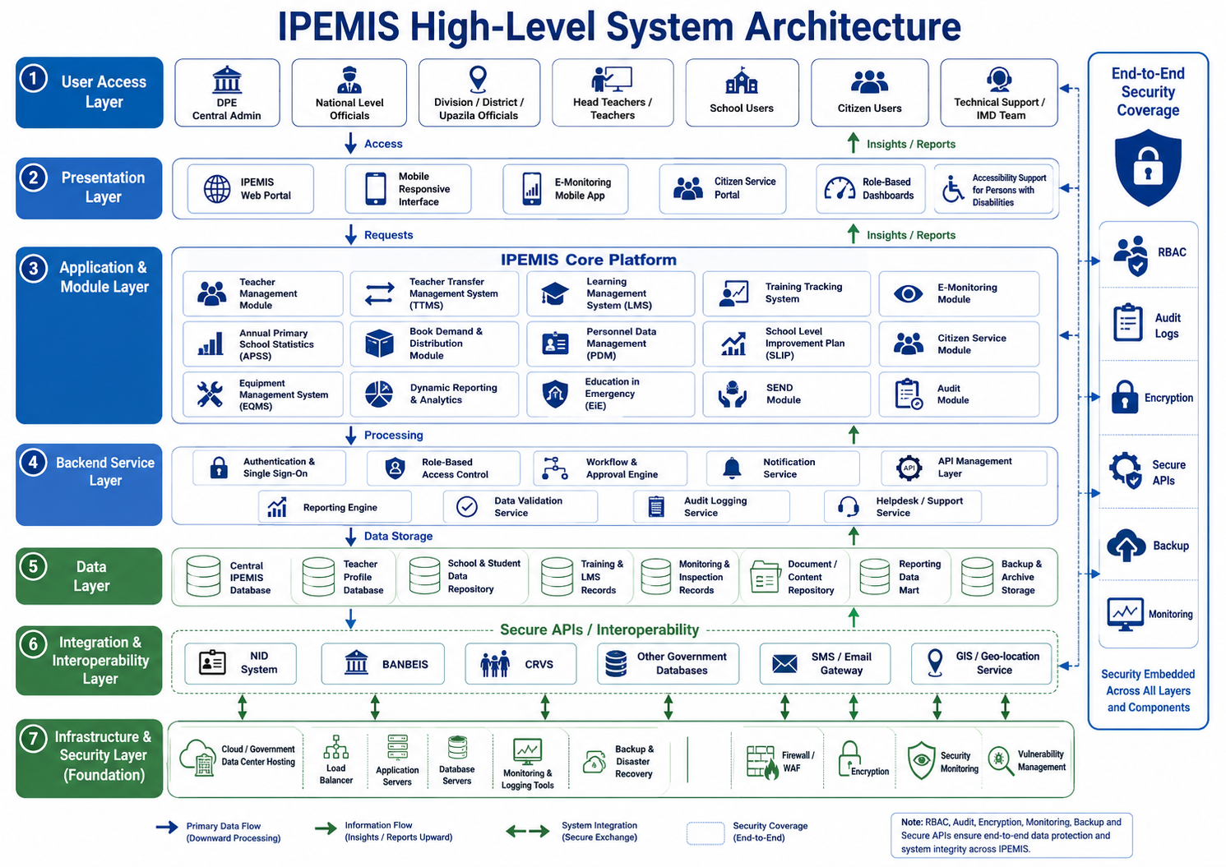
Figure 1: High-level system architecture for IPEMIS.

7. Data Flow Approach
The proposed data flow ensures that data entered at school, field office or central level is validated, approved, processed, stored and converted into decision-ready dashboards and reports. Audit logs and feedback mechanisms will support accountability and continuous data quality improvement.
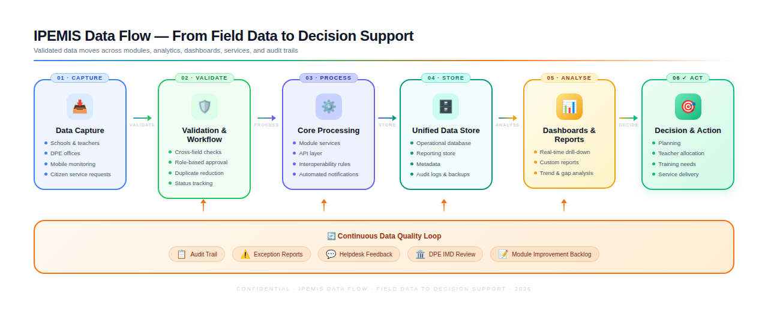
Figure 2: Proposed data flow for validated reporting and decision support.

Data Flow Controls
- Role-wise data entry, review and approval based on module workflow requirements.
- Cross-field validation to reduce incomplete, duplicate or inconsistent data.
- Auto-population from existing authoritative module data where feasible.
- Exception reporting for missing, anomalous or contradictory records.
- Audit trail for create, update, approval, rejection and deletion events.
- Reporting data views to support dashboards without affecting operational performance.

8. Integration Roadmap
The integration roadmap is designed as a controlled sequence rather than a timeline. Each integration will start with data ownership confirmation, data mapping and API contract definition before technical development. The approach aligns with Bangladesh National Digital Architecture principles, including interoperability and e-government service integration.
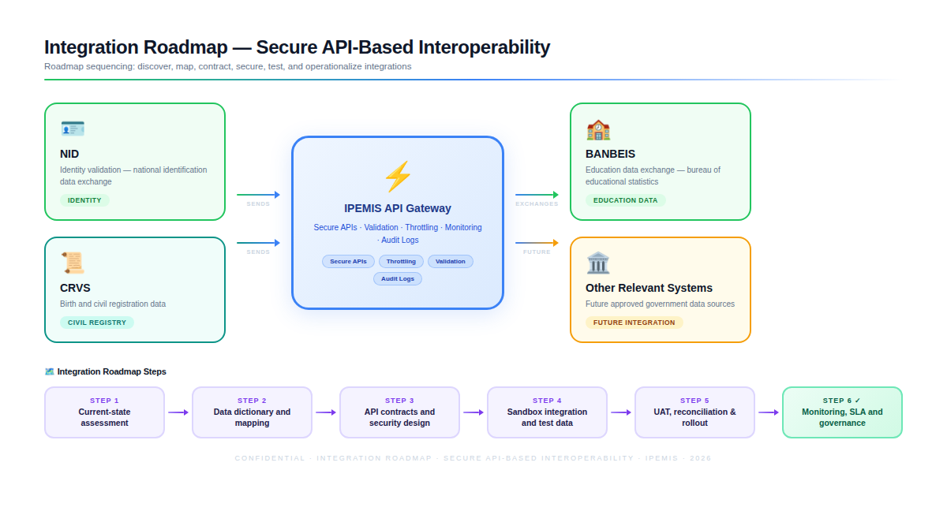
Figure 3: Secure API-based integration roadmap.

Integration Roadmap Steps
Roadmap Step | Key Activities
Current-State Assessment | Review existing IPEMIS integrations, source systems, data ownership, refresh frequency, security constraints and operational dependencies.
Data Dictionary and Mapping | Define common data fields, identifiers, validation rules, data ownership, code lists and reconciliation requirements.
API Contract Design | Prepare API specifications covering endpoints, payloads, authentication, authorization, error codes, logging and versioning.
Secure Connectivity and Sandbox Testing | Set up secure development and test environments with sample or masked data before production integration.
UAT and Reconciliation | Validate integration outputs with DPE users and compare data consistency across source and destination systems.
Operationalization | Deploy approved integrations with monitoring, support procedures, error handling, change control and periodic review.

9 Security Framework
Security will be treated as a built-in platform capability, not as a final-stage activity. The framework below is aligned with the ToR requirements for RBAC, audit systems, secure APIs and compliance with government data protection expectations. Application security verification will be guided by OWASP ASVS 5.0 principles, and accessibility controls will be aligned with WCAG 2.2 where applicable.
Control Area | Proposed Controls
Identity and Access Control | Role-based access control, least privilege, strong password policy, session timeout, approval hierarchy and periodic access review.
API Security | Token-based authentication, API gateway controls, TLS, input validation, throttling, API versioning, request logging and error handling.
Data Protection | Data classification, encryption in transit, sensitive-field protection, backup controls, restricted administrative access and database activity logging.
Audit and Accountability | Full audit trail for user access, data changes, approvals, workflow transitions, system configuration changes and integration events.
Application Security | Secure coding practices, dependency scanning, vulnerability assessment, penetration testing, secure file upload controls and patch management.
Infrastructure and Operations | Environment separation, backup and recovery, monitoring, alerting, uptime tracking, incident response and controlled deployment pipeline.
Privacy and Responsible Data Use | Purpose-based data access, minimum required data exposure, data sharing approvals and clear operational governance for external integrations.

10. Development and Enhancement Strategy
The development strategy will follow an iterative and controlled enhancement model. Each module will move through requirement confirmation, design validation, development, integration, testing, UAT, deployment and post-release stabilization. The strategy supports parallel workstreams while maintaining a shared architecture, shared coding standards and centralized release governance.
- Maintain a single prioritized backlog mapped to the ToR modules and DPE decisions.
- Use module-wise solution design documents before development starts.
- Apply reusable components for forms, approval flows, notifications, dashboards and audit logs.
- Use configurable rules for policy-driven workflows such as teacher transfer, SLIP and APSS validation.
- Separate operational transactions from reporting queries through optimized reporting views where required.
- Use controlled deployment with release notes, rollback readiness and post-release support.
- Ensure source code repository updates, technical documentation and handover for DPE IMD.

Module Enhancement Strategy
Module Type | Enhancement Focus
Workflow-heavy modules | TTMS, PDM, SLIP, citizen service and EQMS will prioritize configurable approval workflow, status tracking and auditability.
Data-heavy modules | Teacher, APSS, book distribution, SEND and EiE will prioritize data quality, validation, auto-population, dashboards and reporting.
Learning and training modules | LMS and training tracker will prioritize course structure, completion tracking, certificates, training modalities and linkage with teacher profile.
Monitoring and analytics modules | E-Monitoring and dynamic reporting will prioritize indicators, inspection schedules, follow-up, drill-down dashboards and decision parameters.

11. Proposed Technical Stack
The final stack will be confirmed after source code and infrastructure assessment. The proposed stack below is practical for a large web-based national education platform and can be adapted to the existing IPEMIS technology environment to reduce cost, risk and rework.
Layer | Recommended Stack / Tools
Frontend | React.js or compatible existing frontend framework; responsive web UI; HTML5, CSS3, JavaScript/TypeScript; accessibility-compliant design system.
Backend | Laravel/PHP or compatible existing backend framework; RESTful API services; modular service layer; queue-based background jobs where required.
Database | PostgreSQL or MySQL/MariaDB depending on existing platform; optimized indexing; reporting views; backup and restore procedures.
Caching and Performance | Redis or equivalent cache; query optimization; load balancing readiness; CDN/static asset optimization where applicable.
API and Integration | REST API gateway, OpenAPI/Swagger documentation, OAuth2/JWT/token-based authentication, secure API logging and versioning.
Reporting and Dashboards | BI-ready reporting views, interactive dashboards, charting library, role-based analytics and drill-down reporting.
DevOps and Deployment | Git-based source control, CI/CD pipeline, environment separation, automated build/deployment scripts, server monitoring and log management.
Security Tooling | SAST/dependency scan, OWASP ZAP or equivalent DAST, vulnerability assessment, security headers, secret management and audit log review.
Documentation | SRS, API specifications, database schema, deployment guide, admin guide, user manual and training materials.

12. Deliverables
Deliverable | Description
Inception Report | Refined methodology, assessment tools, stakeholder consultation plan, risk mitigation strategy and detailed workplan.
SRS and Technical Design | System architecture, interoperability framework, module integration roadmap, database design, security framework, scalability requirements, UI/UX strategy and technical specifications.
Enhanced IPEMIS Modules | Teacher module, TTMS, LMS, training tracker, E-Monitoring, SEND, APSS, book demand and distribution, PDM, SLIP, citizen service, EQMS, dynamic reporting and analytics, EiE and audit module.
UI/UX and Dashboard Deliverables | Improved web/mobile user interface, role-based dashboards, dynamic analytics, drill-down reports and accessibility improvements.
API and Interoperability Deliverables | API specifications, secure API implementation, data mapping documents, integration test reports and operationalization documents.
Security and Performance Deliverables | RBAC, audit logs, performance optimization, scalability improvements, monitoring setup, vulnerability testing and remediation reports.
Testing Deliverables | Test strategy, test cases, QA reports, integration test reports, performance test reports, security test reports and UAT reports.
Deployment and Handover | Deployment reports, release notes, source code repository updates, technical documentation and system administration materials.
Capacity Building | Training materials, user manuals, operational guidelines, administrative guides, training completion reports and helpdesk/resource team support structure.
Maintenance and Support Reports | Bug fixing, troubleshooting, system optimization, continuous enhancement support and sustainability/institutionalization roadmap.

13. Testing and Quality Assurance
QA will be embedded across the lifecycle through requirement validation, test planning, automated and manual testing, UAT support and post-release stabilization. The testing approach will cover module functionality, workflows, data quality, integrations, performance, security, accessibility and usability.
QA Area | Quality Checks
Requirement Review | Trace test cases against approved SRS, module workflows, business rules and acceptance criteria.
Functional Testing | Validate forms, workflows, approvals, notifications, reports, user roles and module-specific functions.
Integration Testing | Test API contracts, data mapping, error handling, synchronization, reconciliation and audit logs for external integrations.
Data Quality Testing | Validate mandatory fields, duplicates, cross-field rules, auto-population, historical data behavior and exception reporting.
Regression Testing | Confirm that enhancements do not break existing IPEMIS modules, reports or user flows.
Performance Testing | Test response time, dashboard loading, concurrent user behavior, database queries, large report generation and scalability readiness.
Security Testing | Perform vulnerability assessment, authentication/authorization testing, input validation, session management and secure API testing.
Accessibility and Usability Testing | Check responsive behavior, keyboard navigation, contrast, form labels, readable dashboards and compatibility for users with disabilities.
UAT Support | Facilitate UAT with DPE users, capture feedback, prioritize fixes and obtain sign-off before release.
Post-Deployment Verification | Verify production release, monitoring, logs, error handling, user access and rollback readiness.

14. Governance, Reporting and Capacity Building

Governance Structure
- Joint planning and review with UNICEF, DPE, IMD and relevant module owners.
- Module-wise focal persons for requirement validation, UAT and sign-off.
- Change control process for new requests, scope clarification and issue prioritization.
- Release governance covering release notes, rollback plan and support handover.
- Technical steering discussion for architecture, security, integration and data standards.

Reporting
- Inception report, progress reports, meeting minutes and technical reports as required by the ToR.
- Module development and deployment reports.
- UAT, integration, security, performance and QA reports.
- Training, workshop and capacity-building completion reports.
- Final report and sustainability/institutionalization roadmap.

Capacity Building
Capacity building will focus on ensuring that DPE officials, teachers, administrators and IMD can operate, support and sustain IPEMIS. Training will cover system use, data entry, dashboards, reporting, administration, support procedures and basic troubleshooting. The ToR target of training 2,800 DPE officials and field-level users will be supported through structured materials, manuals and resource team enablement.

15. Risks and Mitigation
Risk | Mitigation
Incomplete understanding of existing source code or database | Conduct technical assessment and prepare SRS before enhancement development.
Module interdependency may affect existing workflows | Use impact assessment, regression testing and staged deployment.
Data inconsistency across modules and external systems | Define data dictionary, validation rules, reconciliation reports and source-of-truth ownership.
Integration dependency on external agencies | Confirm data sharing approvals, API readiness, sandbox access and fallback process early.
Performance degradation due to reporting load | Use query optimization, reporting views, caching and dashboard performance testing.
User adoption challenges | Use simplified UI/UX, training materials, helpdesk support and field-level resource teams.
Security exposure through APIs or user roles | Apply RBAC, secure API gateway, audit logging, vulnerability testing and access reviews.

16. Assumptions and Dependencies
- DPE/UNICEF will provide access to existing documentation, source code, databases, environments and relevant stakeholders.
- External system integrations will depend on approvals, API availability, data sharing rules and sandbox access from respective agencies.
- Final technical stack and deployment architecture will be confirmed after existing IPEMIS assessment.
- Any new requirement outside the ToR will be handled through change control and will not be added to the base scope automatically.
- Production deployment will follow government hosting, data protection and infrastructure policies.
- UAT sign-off will be provided by designated module owners and DPE focal persons.

17. Conclusion
The proposed strengthening and enhancement of IPEMIS will help DPE operate a more integrated, reliable, and data-driven education management platform. By upgrading priority modules, improving interoperability, strengthening security, and enhancing dashboards, reporting, and user experience, the system will support better planning, monitoring, teacher management, service delivery, and evidence-based decision-making across national, sub-national, and school levels.

